International Conference
Regional Сooperation within BRICS:
Modern Environmental and Nature Management Issues

Petrozavodsk, September 18-20, 2024

Second Circular

Dear colleagues,

on behalf of the Organizing Committee we thank everybody for registering for this conference. This circular provides further information about the conference, its constituent events, as well as travel and accommodation in Petrozavodsk.

CONFERENCE ORGANIZERS:
• National Committee on BRICS Research (NCR BRICS), Russia
• Karelian Research Centre of the Russian Academy of Sciences (KarRC RAS), Russia

The conference is supported by the RITM Carbon Consortium within the Key Innovative Project of National Importance (KIP NI) "Unified National System for Monitoring Climate-active Substances".

PROGRAMMING COMMITTEE
Chairperson:
Bakhmet O.N., Dr.Sci. (Biol.), RAS Corr. Academician, KarRC RAS (Petrozavodsk)
Members:
Yarygina I.Z., Dr.Sci., NCR BRICS (Moscow);
Chizhov V.A., Federation Council of the RF Federal Assembly (Moscow);
Panchenko V.Ya., Dr.Sci., RAS Vice President, RAS Academician (Moscow);
Kalmykov S.N., Dr.Sci., RAS Vice President, RAS Academician (Moscow);
Nemova N.N., Dr.Sci., RAS Academician, Institute of Biology KarRC RAS (Petrozavodsk);
Titov A.F., Dr.Sci., RAS Corr. Academician, Institute of Biology KarRC RAS, Department for Multidisciplinary Research KarRC RAS (Petrozavodsk);
Petrunina I.A., Ministry of Economic Development of the Russian Federation (Moscow);
Mogilevskiy K.I., Cand.Sci., Ministry of Science and Higher Education of the Russian Federation (Moscow);
Kushch I.A., Ministry of Natural Resources and Environment of the Russian Federation (Moscow);
Svidskaya Ya.S., Ministry of Natural Resources and Environment of the Republic of Karelia (Petrozavodsk);
Drissia T.K., PhD, Center for Water Resources Development and Management (India);
Jiang H., PhD, Nanjing Institute of Geography and Limnology, Chinese Academy of Sciences (China);
Maharajh R., PhD, Institute for Economic Research on Innovation, Tshwane University of Technology (South Africa);
Abessa D., PhD, University of São Paulo (Brazil);
Serebritskiy I.A., Committee on Nature Management, Environmental Protection and Environmental Safety, St. Petersburg City Administration;
Seryogin M.F., RAS International Cooperation Administration (Moscow);
Filatov N.N., Dr.Sci., RAS Corr. Academician, Northern Water Problems Institute KarRC RAS (Petrozavodsk);
Slabunov A.I., Dr.Sci., Institute of Geology KarRC RAS (Petrozavodsk);
Ilmast N.V., Dr.Sci., Institute of Biology KarRC RAS (Petrozavodsk);
Kryshen A.M., Dr.Sci., Forest Research Institute KarRC RAS (Petrozavodsk);
Kuznetsov O.L., Dr.Sci., Department for Multidisciplinary Research KarRC RAS (Petrozavodsk);
Lukina Yu.N., Dr.Sci., Northern Water Problems Institute KarRC RAS (Petrozavodsk);
Morozova T.V., Dr.Sci., Institute of Economics KarRC RAS (Petrozavodsk);
Svetov S.A., Dr.Sci., Institute of Geology KarRC RAS (Petrozavodsk).

ORGANIZING COMMITTEE
Chairperson: Bakhmet O.N., Dr.Sci., RAS Corr. Academician, KarRC RAS Acting Director General
Executive Secretary: Smirnova A.A., Acting Head of KarRC RAS Department for International Cooperation

Members:

Bazegskiy D.V., Cand.Sci.;
Fokina N.N., Cand.Sci.;
Kondratyeva S.V., Cand.Sci.;
Tolstikov A.V., Cand.Sci.;
Yekimov D.A., Cand.Sci.;
Kulakova L.M., Cand.Sci.;
Tikhomirov I.S. (NCR BRICS);
Vinogradova T.V.;
Markova V.A.;
Mikhailova N.V., Cand.Sci.;
Tsvetkov A.M.;
Bedorev A.A.;
Grodnitskiy A.M.;
Krizhanovskaya N.B.;
Shvetsova V.O.

The following topics will be discussed at the plenary and thematic sessions:
- Global and regional climate change, carbon balance monitoring in BRICS member states
- Water and terrestrial ecosystems research under climate change and human impact in BRICS member states
- Topical issues of PA designation and nature protection in BRICS member states: opportunities for cooperation
- Development of industrial ecology and green economy: regional experiences
- Expanding interaction on Arctic affairs
- Promoting young scientists interaction on the said topics
- Issues of civil society interaction

SIMULTANEOUS EVENTS WITHIN THE CONFERENCE
1. A side event of the conference on September 18, 2024 will be the roundtable for young scientists and specialists Monitoring Carbon Pools and Fluxes in Natural Ecosystems, organized with support from RITM Carbon Consortium as part of KarRC RAS activities within the Key Innovative Project of National Importance (KIP NI) "Unified National System for Monitoring Climate-active Substances". Master's degree students, as well as doctoral students and young scientists of Russian and foreign educational and scientific organizations are invited to participate. Applicants are required to fill out the registration form (Appendix 3) and indicate research interests/achievements as statement of motivation. The costs of travel and accommodation in Petrozavodsk will be reimbursed by the host. The number of participants is limited.
Contacts for Youth Roundtable participants:
Varvara Markova: vmarkova@krc.karelia.ru.

2. The call is open for applications for the roundtable of experts in social and political sciences BRICS+ as a Platform for Scientific Cooperation in the Arctic: Challenges and Prospects of Joint Research, to take place at KarRC RAS on September 19, 2024. Presentation topics: BRICS+ Arctic at the current stage; Ensuring environmental security in the Arctic; Socio-economic and environmental transformations in Arctic regions; Green solutions of international cooperation for regional development (Arctic Council, Barents Euro-Arctic Council, Russia-EU cross-border cooperation programs). The costs of participation in the event are to be covered by the assigning party.
Contacts for Arctic Research Roundtable participants:
Artyom Grodnitskiy: agrodn@krc.karelia.ru.

3. On September 19th, the KarRC RAS will host the session The Potential and International Activities of NGOs in Working towards Sustainable Territorial Development under Modern Conditions.
Due to the ending of cross-border cooperation programs and joint activities in the Northern Europe the expertise in people’s diplomacy for promoting sustainable territorial development and population safeguarding, accumulated by the non-governmental sector of the Russian Karelia, opens up new opportunities for expanding the international networking geography. This session is designed to further non-governmental cooperation within BRICS countries, consolidate its efforts in attaining sustainable development goals, foster constructive and mutually beneficial international dialog, and to establish steady civil society associations.
We invite NGOs from Russia and other countries to participate in the event. The topics include strategizing, communication, and education. The experience and best practices of NGOs interregional and international cooperation will be presented.
Contacts for the session on promoting NGOs interaction:
Lyubov Kulakova, Senior Researcher, Regional Economic Policy Department, Institute of Economics KarRC RAS, Director of Karjala (Karelia) Territorial Development Foundation: dialogkarelia@gmail.com

ACCOMMODATION OF PARTICIPANTS
Please be aware that participants are to plan and pay for their trips around the city and accommodation themselves. The conferences dates, September 18-20, is high season in Karelia, so we kindly ask you to take care of your tickets and hotel booking in advance.
For your convenience, some Petrozavodsk hotels (PITER INN, Petra, Frigate, and Severnaya) will offer special deals to the conference participants – price discounts with the promo code (the promo code can be copied and entered into the designated field when booking online or communicated to the manager on the phone).
ACCOMMODATION OPTIONS:
1. PITER INN Hotel: Address: 1 Gagarin Sq.: www.piterinn.com.
Conference participants can get a special discounted price on September 18-20 with the promo code БРИКС.

2. Petra Hotel: Address: 24 Anokhina St. (2nd floor): www.petrahotel.ru.
Conference participants can get a special discounted price on September 18-20 with the promo code НАУКА.

3. Severnaya Hotel: Address: 21 Lenin Ave: www.severnaya.info.
Conference participants can get a special discounted price on September 18-20 with the promo code НАУКА.

4. Frigate Hotel: Address: 1a Karl Marx Ave: www.frigatehotel.ru.
Conference participants can get a special discounted price on September 18-20 with the promo code БРИКС.

5. Cosmos Petrozavodsk Hotel: Address: 26 Kuibysheva St.: www.petrozavodsk.cosmosgroup.ru

6. Prionezhsky Hotel: Address: 46 Fedosovoy St.: www.отель-прионежский.рф

7. Onega Castle Hotel: Address: 44 Fedosovoy St.: www.onegacastle-hotel.ru

8. Harland Mini Hotel: Address: 17 Kuibysheva St.: www.harlandptz.ru

9. Sakvoayazh Hotel: Address: 10 Sverdlova St.: www.rk-hotel.ru

10. Aquatika Hotel: Address: 7 Pushkinskaya St. phone:+7 (8142) 76‒50‒04

11. Maski Hotel: Address: 3а Karl Marx Ave. phone: +7 (8142) 77‒46‒19

12. Karelia Spa Hotel: Address: 2 Nab. Gyllinga: www.karelia-hotel.ru

13. Aurinko Hotel: Address: 7 Nab. Gyllinga: www.otel-karelia.ru

14. Lahti Hotel: Address: 7a Rigachina St.: www.lahtitur.ru

HOTELS ON THE MAP
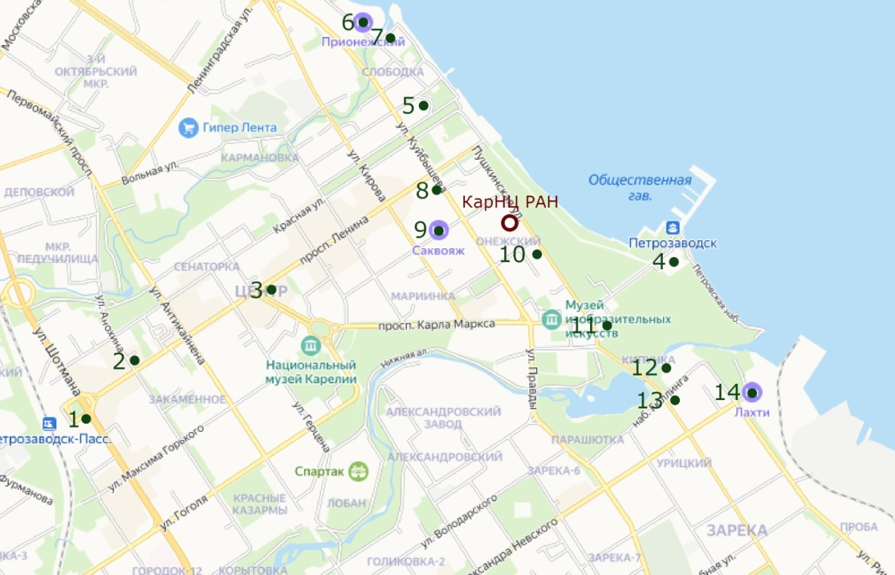
STAYING IN PETROZAVODSK AND THE SOCIAL PROGRAM
After the sessions on September 19th are over, the participants will be invited to visit the museums and exhibitions at KarRC RAS (to choose from):
- Museum of Precambrian Geology
- Museum of Applied Environmental Research
- Abnormal Wood Collection
- Archaeological Museum
These free tours will be guided by KarRC RAS staff. Provisional timeframe for visiting exhibitions at KarRC RAS is 14:00-17:00.

OTHER TOURS:
On September 20th, tours will be arranged to natural destinations in the Republic of Karelia with three options to choose from:
• Kivach Nature Reserve and Girvas Paleovolcano;
• Shoksha crimson quartzite deposit and Shyoltozero Veps Ethnographic Museum;
• Tour of Petrozavodsk including Vodlozersky National Park Visitor Center.
The tours will be accompanied by researchers from KarRC RAS and will be free of extra charge for the conference participants.
Please inform the Organizing Committee of your willingness to go on specific KarRC RAS museum tours and tours to other destinations before September 1st at BRICSconf@krc.karelia.ru.

REGISTRATION
To register as a participant, fill out and submit the Registration form (Appendix 1) not later than July 31, 2024 to the Organizing Committee at BRICSconf@krc.karelia.ru, as well as the abstract of your paper (see format guidelines in Appendix 2). Participants of the youth roundtable on carbon are to fill out a separate form (Appendix 3).
The number of participants is limited. The Organizing Committee reserves the right to select applications for participation in the Conference.
OFFICIAL INVITATION
Please inform the Organizing Committee if you need an official invitation for coming to the Conference and obtaining visas.
PRESENTATIONS
Provisional time allocated per presentation is 20 minutes (15 min for presentation, 5 min for Q&A). The presentation is to be made as a Microsoft PowerPoint presentation (*.ppt) or a Portable Document Format file (*.pdf) to be demonstrated using a slide projector.
The Conference will take place in both online and offline formats for speakers and in offline format (including poster session) for non-presenting participants.
The Conference languages are Russian and English.
Participants are expected to pay for their own accommodation, travel to and from the conference venue, as well as excursion programs. Some travel grants may be offered to leading international experts and young scientists.
An electronic book of abstracts will be published after the Conference. Since the number of participants is limited, the Organizing Committee reserves the right to select the abstracts for publishing.

KEY DATES AND DEADLINES:
June 1 – July 31, 2024 – Second Circular is sent out
July 31, 2024 – deadline for submitting applications and abstracts
August 1–31, 2024 - Third Circular and draft program sent out
September 18–19, 2024 – conference sessions
September 20, 2024 – excursions

ORGANIZING COMMITTEE CONTACTS
E-mail: BRICSconf@krc.karelia.ru
Phone: +78142780109 – regarding invitations, program, accommodation, excursions
Conference webpage: http://www.krc.karelia.ru/bricsconf.

Appendix 1

REGISTRATION FORM FOR THE CONFERENCE
REGIONAL COOPERATION WITHIN BRICS:
MODERN ENVIRONMENTAL AND NATURE MANAGEMENT ISSUES

Surname
Given name(s)
Patronymic (if any)
Academic degree, title, position
Affiliation
Phone number
E-mail (required)
Participation format (offline / online)

Paper title and authors
Period of stay in Petrozavodsk

Appendix 2

ABSTRACT FORMAT GUIDELINES FOR THE CONFERENCE
REGIONAL COOPERATION WITHIN BRICS: MODERN ENVIRONMENTAL AND NATURE MANAGEMENT ISSUES

The abstract must not exceed 1 page (А4 format). Font - Times New Roman (no styles or macros), font size 12. Paragraph indent - 1 cm. Single line spacing. Margins - 2 cm on all sides. Auto hyphenation. Figures and tables are to be numbered consecutively, supplied with thematic captions and positioned in the page directly after the mention in the text.
The text should be supplied with the following information: paper title (capital letters, 12 pt, center-aligned, bold, no hyphenation); next line – authors’ names (12 pt, italicized, center-aligned, separate authors’ names by commas if there are two or more authors); next line – affiliation, city, country (12 pt, center-aligned); next line – speaker’s e-mail. Authors with different affiliations should be marked by numerical indexes in uppercase. If the authors are affiliated with different organizations, each organization is indicated in a separate line. The text may contain references to the literature. A reference states the surname of the first author or the first word in the title, and the year of publication, e.g. (Smith, 2015). The literature used is given at the end of the text as the "List of References:".
Abstracts are to be e-mailed not later than July 31, 2024 at BRICSconf@krc.karelia.ru with a Word document (*.docx) or a Word 97–2003 document (*.doc) file in the attachment. Use the first author’s surname as the file name (e.g., Smith.docx).

Appendix 3

REGISTRATION FORM FOR THE CONFERENCE
REGIONAL COOPERATION WITHIN BRICS:
MODERN ENVIRONMENTAL AND NATURE MANAGEMENT ISSUES
YOUTH SESSION
MONITORING CARBON POOLS AND FLUXES IN NATURAL ECOSYSTEMS
(September 18-20, 2024)
Surname
Given name(s)
Patronymic (if any)
Academic degree, title, position/ education major, year of study
Affiliation (institute/department)
Phone number
E-mail (required)
Participation format (offline / online)
Period of stay in Petrozavodsk

Please describe your research area and explain why you’re interested in participating (1000 symbols)

